Lab - Guideline

Topics
- IPv6 – Intro
- IPv6 – Static routing

- Commands – routing table

Netstat and route commands
netstat –r
route print
Netsh commands
netsh>
interface ipv6
interface ipv6 show …
interface ipv6 add address …
interface ipv6 add route …
interface ipv6 add dnsserver …

Examples: http://computernetworkingnotes.com/ipv6-features-concepts-and-configurations/ipv6-address.html

IPv6 has 128-bit source and destination addresses

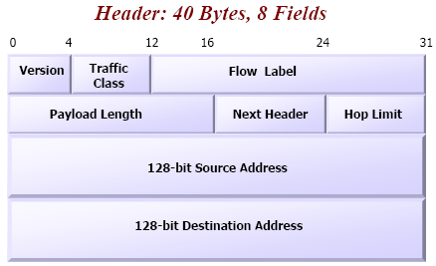
IPv6 header

An IPv6 address is formed by two entities: prefix and interface id

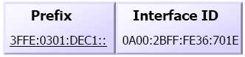

IPv6 Addresses:
- Unicast, Multicast, Anycast

Unicast Addresses
- global
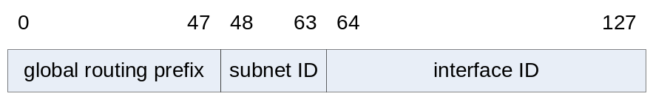
- private
  - Link local (for a link, used for address configuration, neighbor discovery):
stars with FE80::/10 - FEB0::/10 prefix
  - Site local (for an organization):
stars with FEC0::/10 - FEF0::/10 prefix

Adresele Multicast
0 7 | 8 11 | 12 15 | 16 127
Indicator (FF) | Flags 000T (transient flag) | Scope ID | Group ID
FF | IF T =0 well known multicast (permanent)  IF T =1 transient | node-local=1, link-local=2, site-local=5, organization-local=8, global=14
- Well-known Multicast Groups
  - solicited-node
  - all nodes
  - all routers

Anycast Addresses
- “send to any one member of this group”

Global addresses auto-configuration
- Stateless – router
  - Link-Local Address Generation
  - Link-Local Address Uniqueness Test: sends a Neighbor Solicitation message using the Neighbor Discovery (ND) protocol to check if it is unique
  - Link-Local Address Assignment
  - Router Contact
    - listening for Router Advertisement messages sent periodically by routers or
    - by sending a specific Router Solicitation to ask a router for information
  - Router Direction: specifica daca e retea statefull spunand adresa DHCP server sau trimite prefixul, daca e stateless
  - Global Address Configuration
- Statefull - DHCPv6

- IPv6 – static routing

Laboratory test configuration:

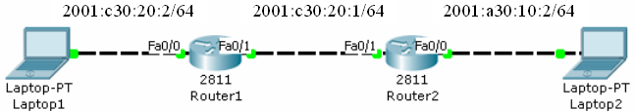

Step0: Enter configuration mode and configure ipv6 unicast routing (enables the forwarding of IPv6 unicast datagrams)

Router>enable
Router#configure terminal
Router(config)# ipv6 unicast-routing

Step1: Assign static IPv6 addresses to router interfaces and computers

General syntax:
Router(config-if)#ipv6 address ipv6-address/prefix-length [eui-64]

Example:

Router(config)#interface fastEthernet 0/0
Router(config-if)#ipv6 address 2001:C30:20:2:209:7CFF:FE4D:1501/64
Router(config-if)#no shutdown

or

Router(config)#interface fastEthernet 0/0
Router(config-if)#ipv6 address 2001:C30:20:2::/64 eui-64
Router(config-if)#no shutdown

Step1a: Show IPv6 address of the interface fastEthernet 0/0
Router(config-if)#end
Router#show ipv6 interface fastEthernet 0/0

Step2: Set static routes

General syntax:
Router(config)#ipv6 route ipv6-prefix/prefix-length next_hop_ipv6 address/interface

Example:

Router(config)#ipv6 unicast-routing
Description: enable the forwarding of IPv6 packets between interfaces on the router

Prefixul retelei destinatie
Next Hop –
IPul de pe interfata Fa0/1 pe ruterul Router2

Router1(config)# ipv6 route 2001:A30:10:2::/64 2001:C30:20:1:290:2BFF:FE71:6702
Description: configure a static route to 2001:A30:10:2::/64 network

Router#show ipv6 route
Description: Visualize the routing table

Test the connectivity.

  - ping <target IP>
  - tracert <target IP>

